**Press Release**

**All INDIA PLASTICS ASSOCIATIONS MEET**

**9th Dec 2019, Hotel Taj Santa Cruz, Mumbai**

**The All India Plastics Manufacturers Association (AIPMA)**

**HIGHLIGHTS**

**Common Stand of 30 Plastics Associations all over India**

1. **Government of India should not increase import duty on polymers (raw material) in order to save domestic plastics processing industry**

* Import duty on PE and PP should be kept at 7.5%
* Import duty on PVC should be reduced from 10% to 7.5%
* Import duty on PET should be kept at 5%
* Import duty on SAN, ABS to brought down to 5%
* Import duty on Polystyrene should be kept at 7.5%

1. **Delta of minimum 10% should be maintained between custom duty of raw material and plastics finished goods.**
2. **Impose Anti-Dumping or Safeguard Duty on import of cheap Finished Products**
3. **All existing FTA’s should be reviewed and plastics finished /semi-finished goods should be excluded from all FTAs.**
4. **BIS standards should not be made mandatory on raw material as it will create price rise and disruption in the industry. BIS and international standards should be treated at par.**
5. **BIS standards should not be made mandatory on plastics finished goods.**
6. **Long pending proposal for Technology Upgradation Fund for plastics industry should be implemented immediately**
7. **Exponential increase in Insurance premium for the industry should be rolled back immediately.**

The All India Plastics Manufacturers Association (AIPMA), a 74-year-old and the largest Industry association in India representing 22,000 industrial units organized an **Emergency All India Plastics Associations Meet** in Hotel Taj Santa Cruz, Mumbai on **9th December 2019**. The meeting was called in wake of **emergency measures that needs to be taken by Government of India to revive the industry and put it back on the growth trajectory**. The All India Plastics Association Meet was attended by more than **70 participants representing 31 industry associations from across the country, industry champions and other key stakeholders**. Mr. Jagat Killawala, President of The All India Plastics Manufacturers Association said that the Plastic Industry is one of the major contributors to the Indian economy and is expected to play a key role in India becoming US $5 Trillion Economy. Mr. Killawala further reiterated that Government should engage strongly with the industry to ideate and implement impactful policy solutions for higher growth.

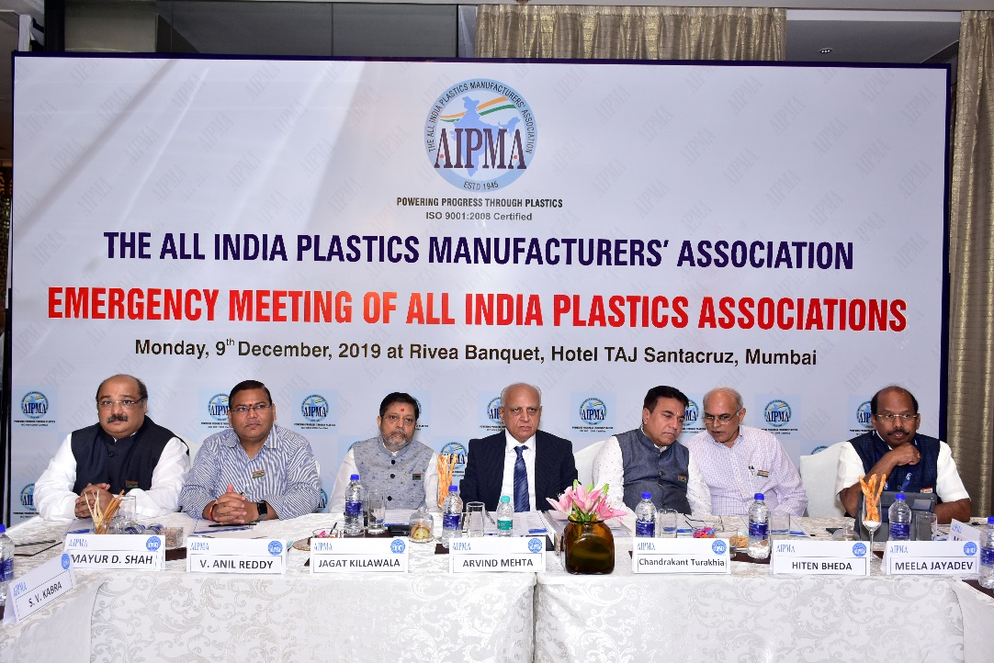

The industry is currently witnessing depression in the market which has led the industry to halt their expansion and investment plans said Mr. Arvind Mehta, Chairman, Governing Council, AIPMA. Mr. Mehta further highlighted the need for Government to come out with clear cut plans and strategy on various fronts in order to spur growth.

Major Plastics Association present were Gujarat State Plastic Manufacturers' Association, Organization of Plastics Processors of India Maharashtra Plastic Manufacturers Association, Karnataka State Plastics Association,South Gujarat Plastic Manufacturer's Association, Saurashtra Plastic Manufacturers' Association, Pimpri Chinchwad Plastic Association , Telangana and Andhra Plastics Manufacturers Association, Indian Plastics Federation, Plastics Export Promotion Council

**The industry deliberated on many critical issues and came to a common stand on following key issues: -**

1. **Restructuring of Custom duties**
2. **Anti-Dumping or Safeguard Duty to be applied on import of cheap Finished Products**
3. **Review of Foreign Trade Agreements**
4. **Enforcement of mandatory BIS standards**
5. **Technology Upgradation fund for the industry**

**Taking in to account the short term as well as long term growth of plastics processing industry, the industry associations unanimously demanded government to not come under pressure from any quarter to increase custom duty on key raw material.** The industry demanded that **custom duty of PVC should be brought down from 10% to 7.5%** as nearly 50% of demand in India is being met through imports due to lack of domestic capacity. Any increase in custom duty will affect the agriculture sector due to high use of PVC pipes and fittings. **Custom duty of Polypropylene and Polyethylene should be retained at 7.5%.** If increased, it would have adverse effect on automotive, healthcare segments and would lead to cost increases in the value chain**.** Increasing Tariff for PET will affect the processing and consumer segment thus **tariff for PET should be retained to 5%** to nurture consumer products consumption. It was further demanded that the **custom duty on SAN and ABS should be brought to 5%** to nurture associated industries growth.

The plastics processing industry comprises of over 50,000 Micro and small units employing around 50 lakhs people. It is a major contributor to the Indian economy **manufacturing goods work Rs. 3.75 Lakhs crore annually**. However, it is under severe strain due to cheap imports from China and other south Asian countries. **Industry demanded that the Delta of minimum 10% should be maintained between custom duty of raw material and plastics finished goods**.

The domestic industry is suffering due to dumping by China and other countries at very cheap cost. **Industry demanded that to prevent under invoicing by foreign players, floor pricing should be established on finished goods**. It also demanded that The Directorate General of Trade Remedies should recommended **anti-dumping duty on plastics finished goods** originating in or imported from 3 major dumpers including China for a period of at least five years.

Existing FTAs with various countries have failed. It has resulted in massive import of finished goods from FTA countries in to India at zero or concessional duty badly affective competitiveness of Indian plastics processing industry. However, export from India to these countries have marginally grown leading to huge trade imbalance. Therefore, Industry demanded that **all existing FTA’s be reviewed and Polymers and Products made of Polymers shall be excluded from all FTAs**.

**Government of India is planning to enforce mandatory BIS standards on raw material**. **Industry felt that this move would put small enterprises to disadvantage** and allowing imports of semi-finished and finished products which are made from very raw materials which are being denied entry by imposing non-tariff barrier to trade (NTBT) would not be in the best interest of nation. **BIS standards should not be made mandatory on raw material. Industry demanded that both BIS or international standards should be considered at par**. This would avoid unnecessary compliance burden on the raw material suppliers and at the same time ensure import of safe and quality material.

On the other hand, **Small units would face major disruption if BIS standards are made mandatory on plastics finished goods** due to compliance burden, high cost of certifications and renewal, non-availability of adequate facilities for testing and harassment by authorities. **BIS standards should not be made mandatory on plastics finished goods.**

The plastics industry demanded that the **long pending proposal for Technology Upgradation Fund on the lines of Textile industry should be implemented immediately** to spur export growth.

**Industry raised serious concerns with respect to insurance companies exponentially increasing are premium for providing insurance coverage against fire and safety**. Industry is also deeply distressed as most of the insurance companies are declining to provide insurance coverage to MSME’s in plastics processing industry. **Industry demanded government to** **immediately roll back the increase of insurance premium** as this is detrimental to the efforts to help the MSMEs for increasing their market share and increase their contribution in the GDP.